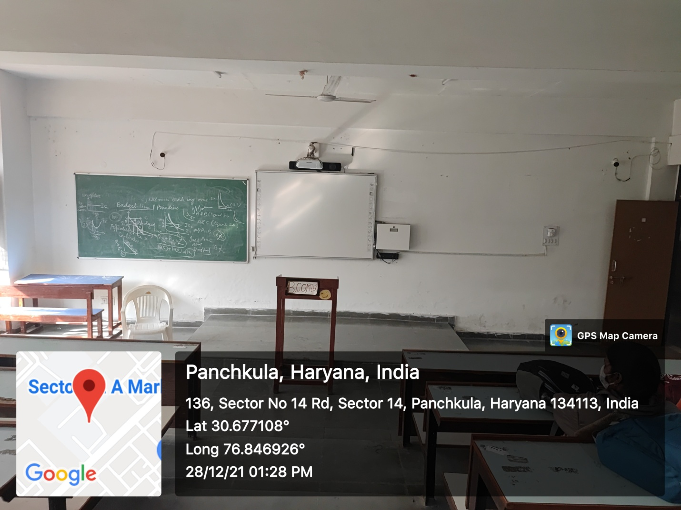
ROOM No.412
(EDUSAT ROOM )

