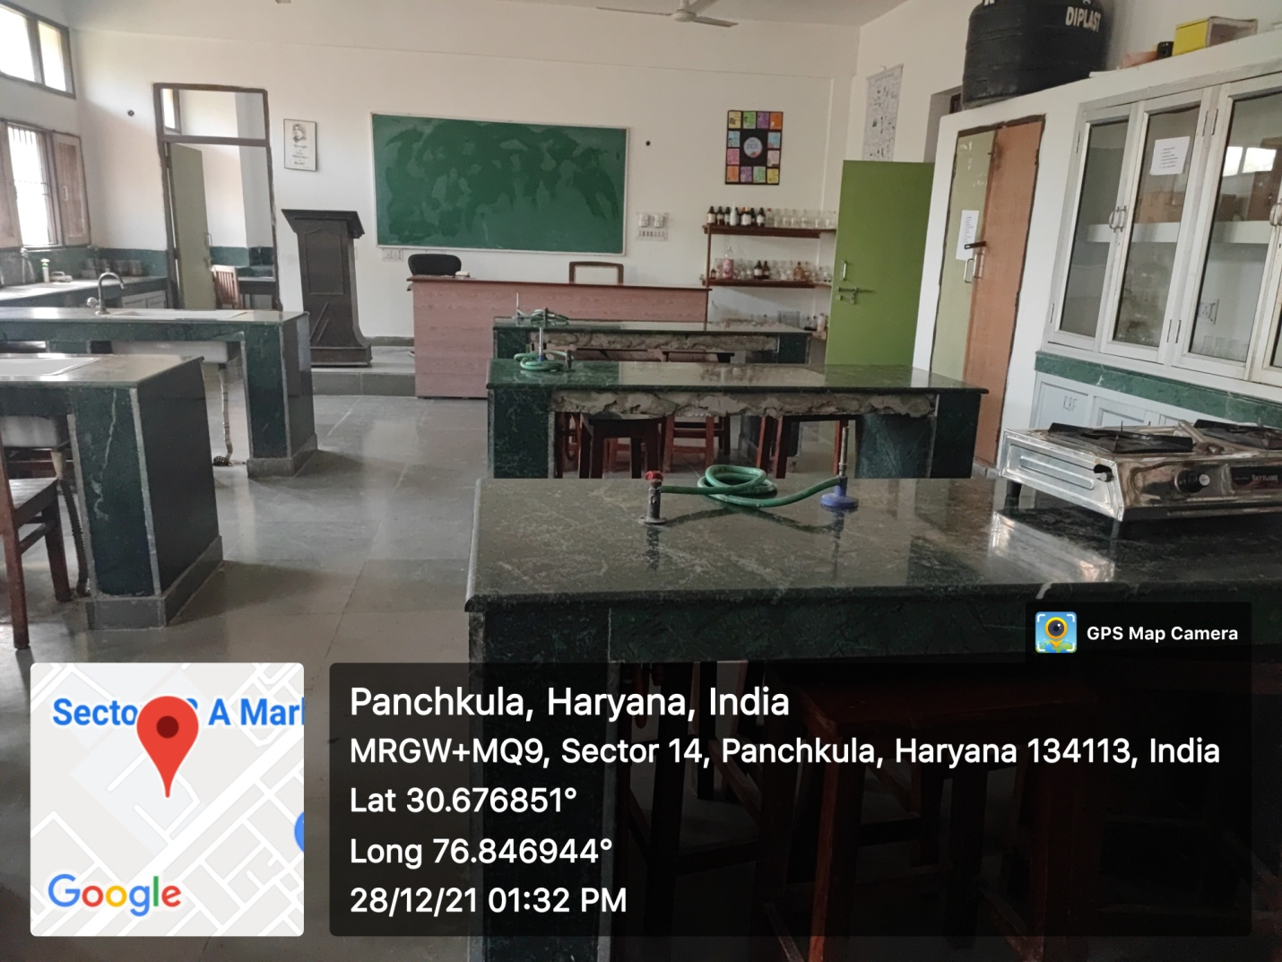

ROOM No.124(CHEMISTRY)
(PROJECTOR ENABLED LAB)

