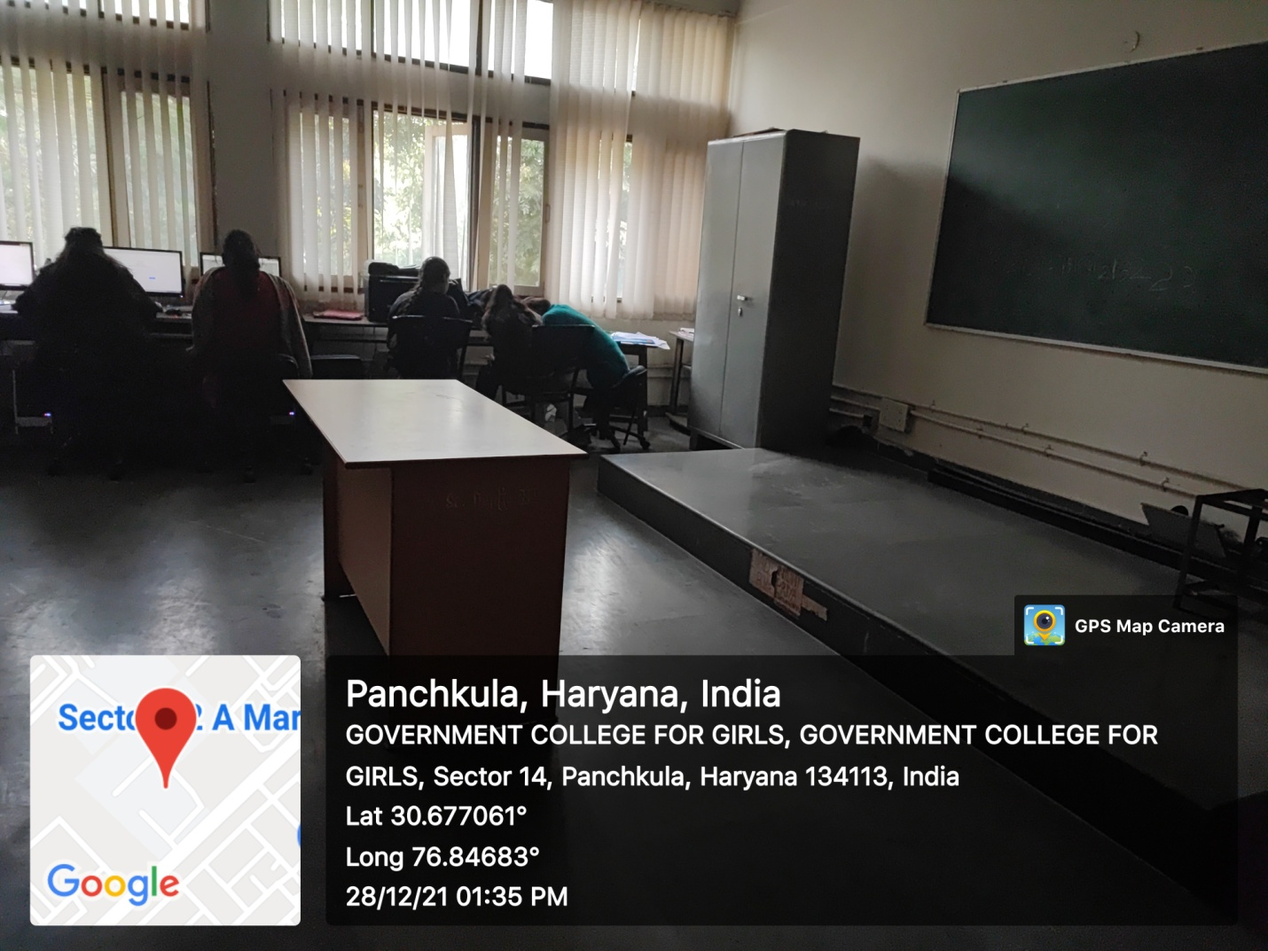

ROOM No.207
(Wifi/LAN/Computer Networking/Smart Board)

