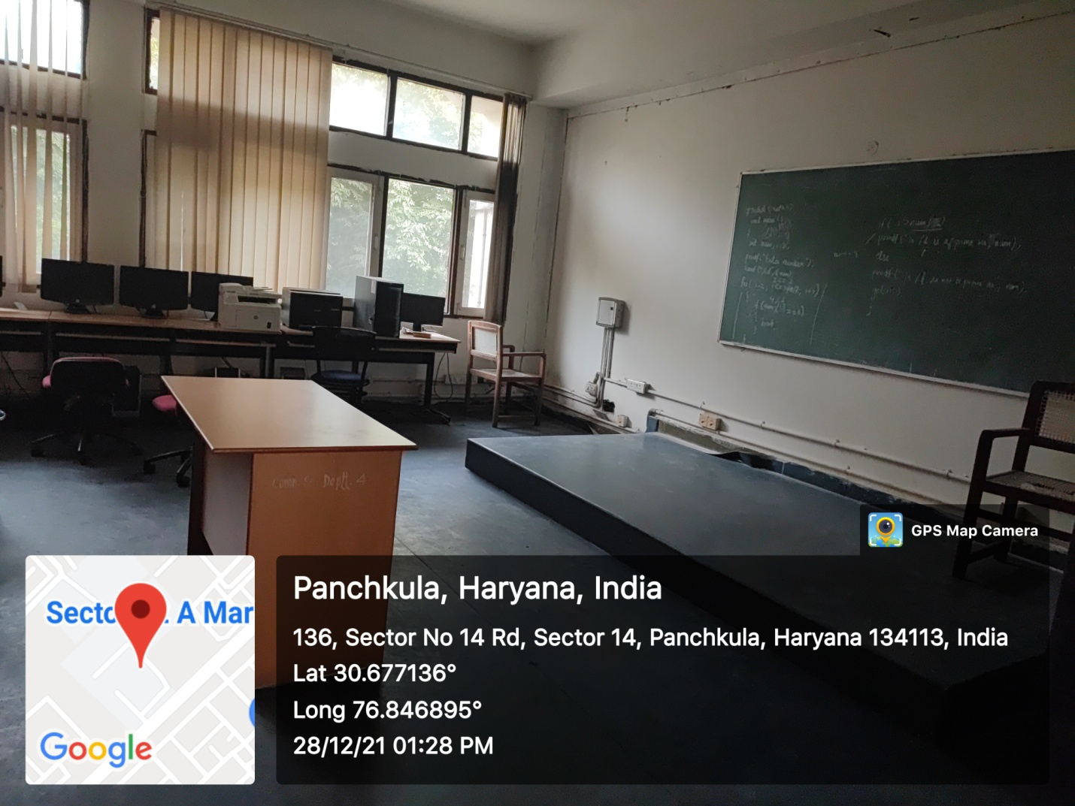

ROOM No.208
(Wifi/LAN/Computer Networking)

