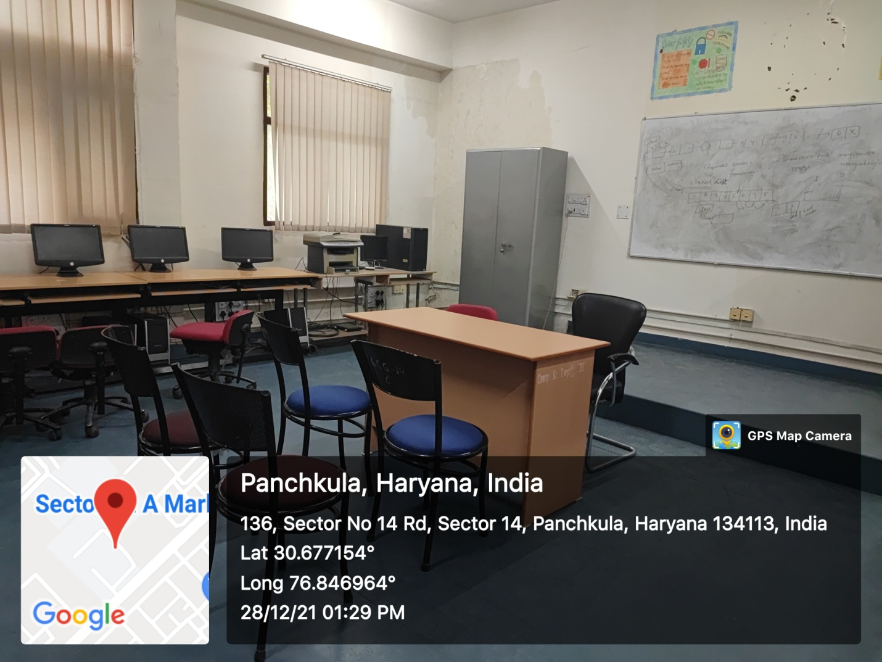

ROOM No. 210
(Wi-Fi/LAN/Computer Networking/ Smart Board)

