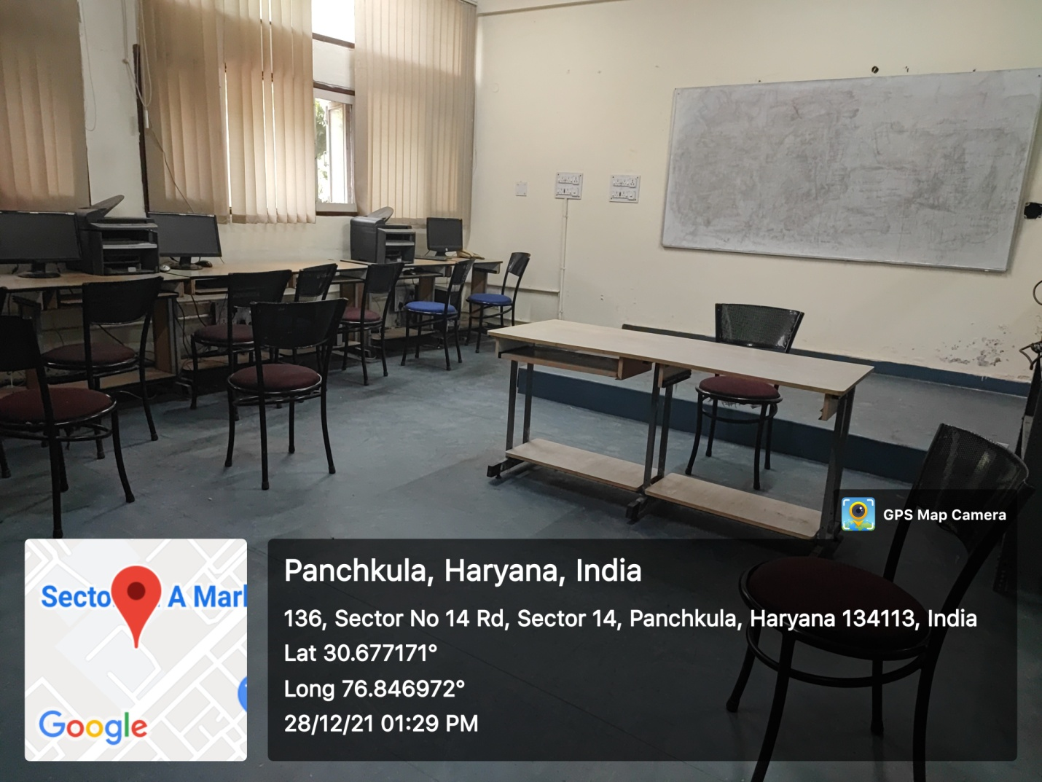

ROOM No.213
(Wifi/LAN/Computer Networking)

