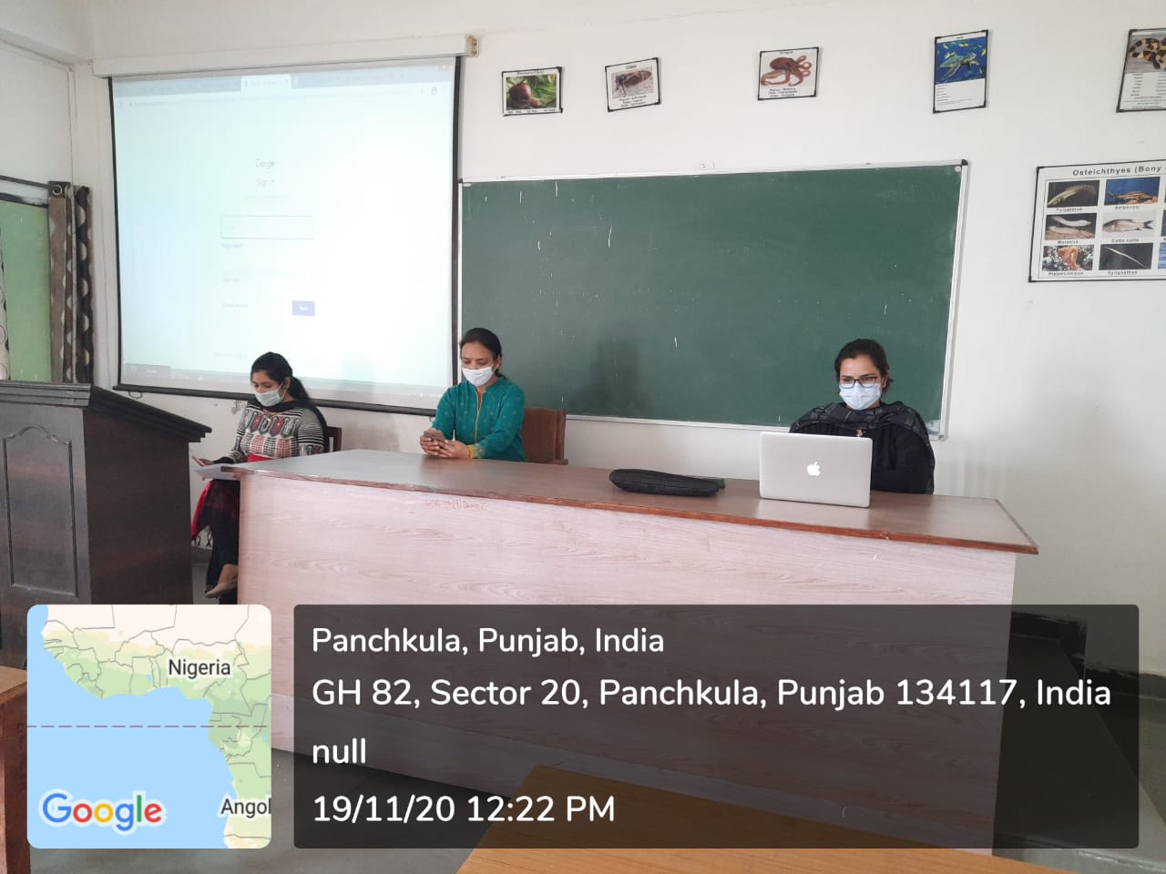
ROOM No.329
(PROJECTOR ENABLED )

