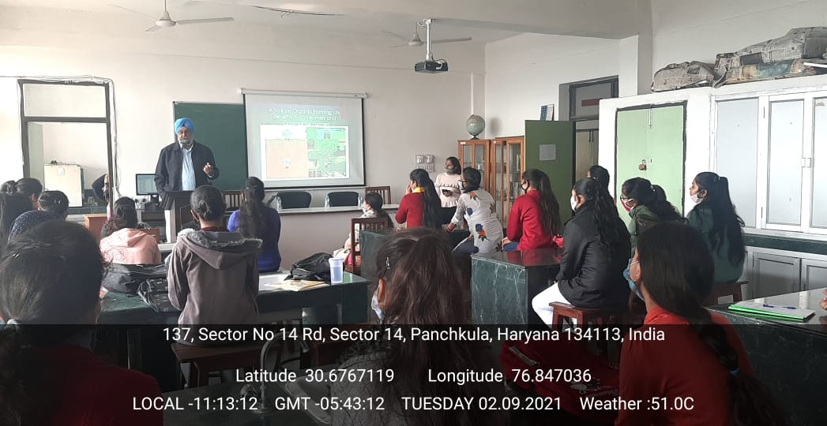

ROOM No. 331
(PROJECTOR ENABLED LAB)

