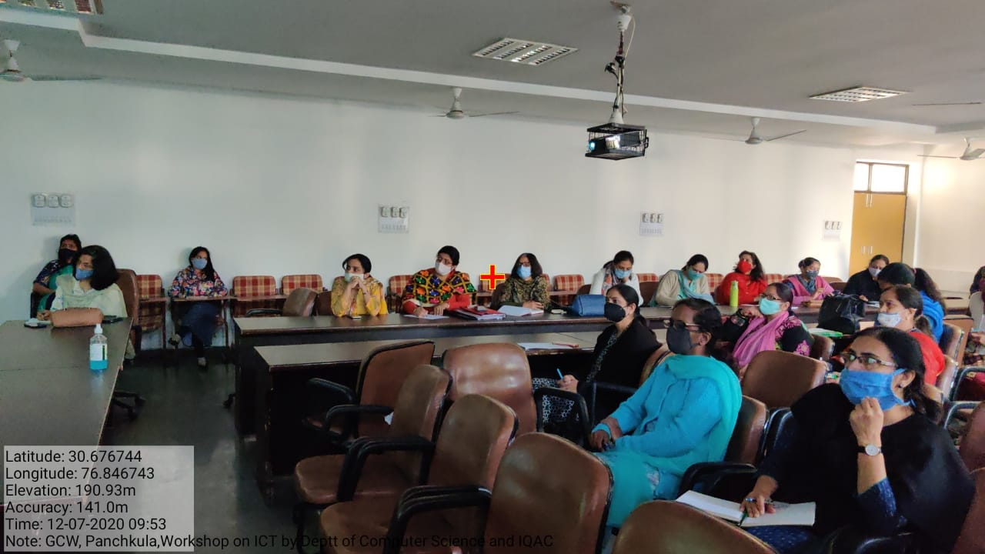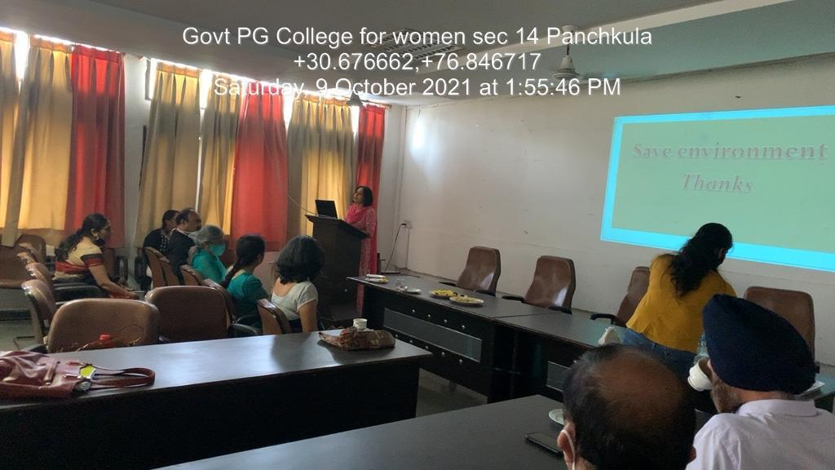

PROJECTOR ENABLED (ROOM No.-202)
SEMINAR HALL

