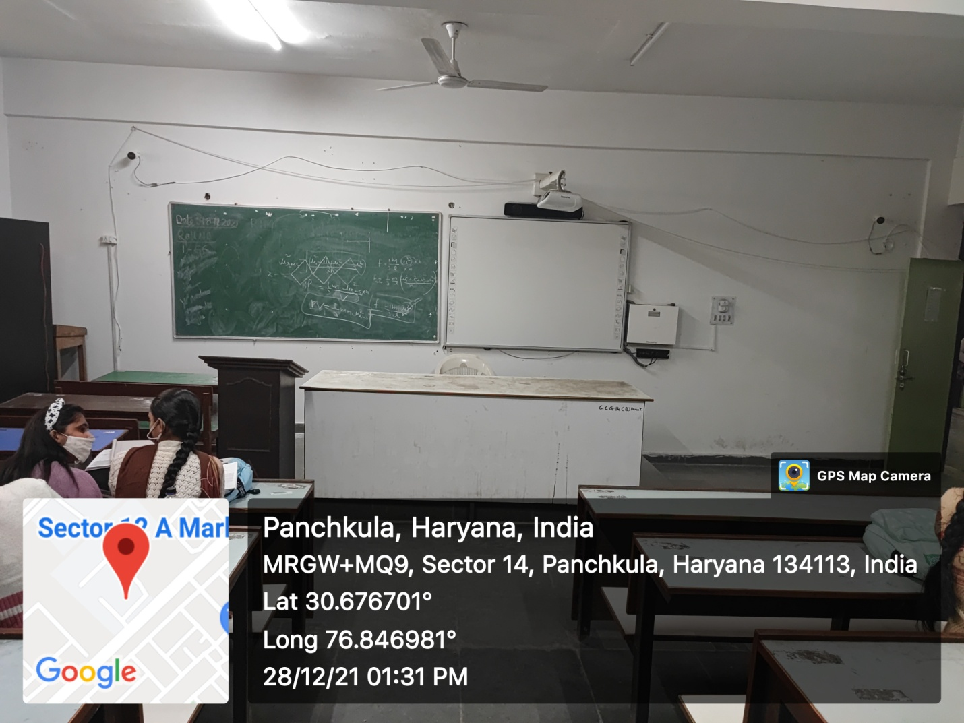

ROOM No.123
(Smart Class-Room)

