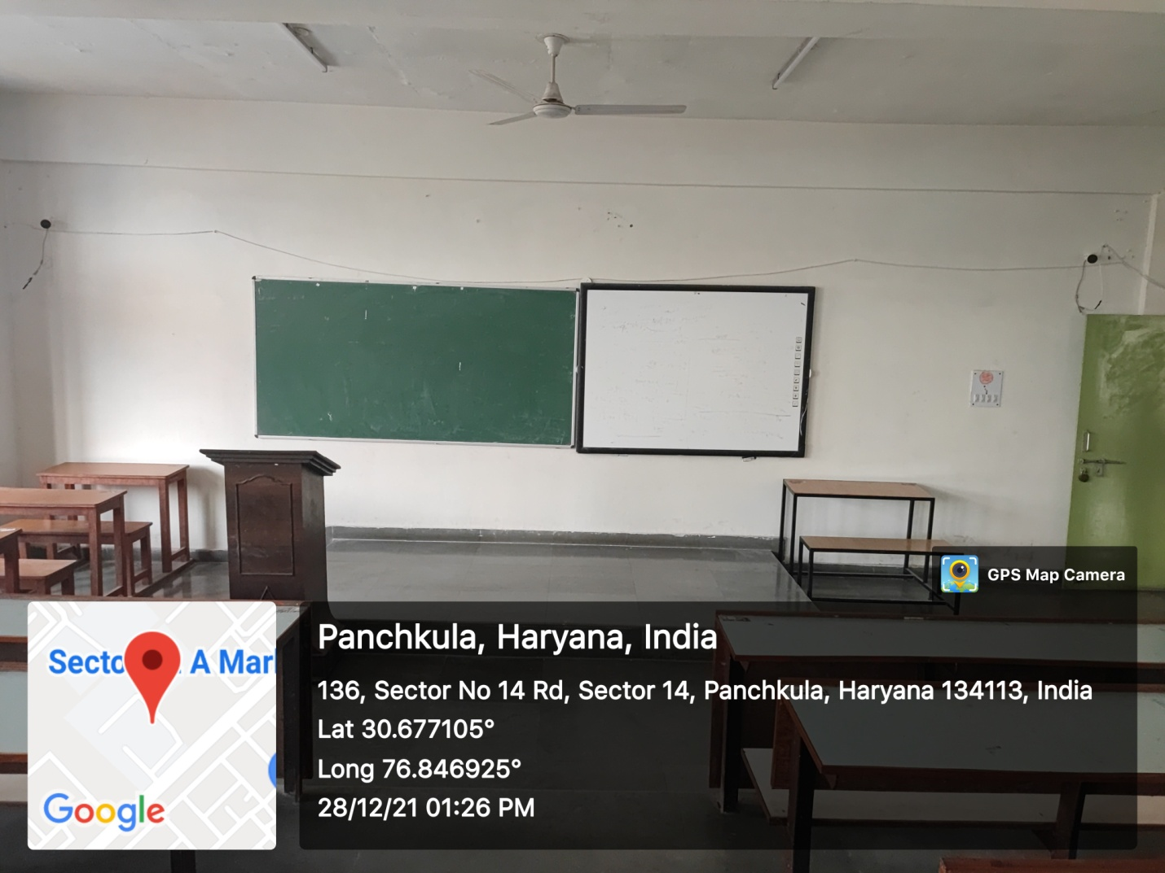
ROOM No.318
(Smart Class-Room)

