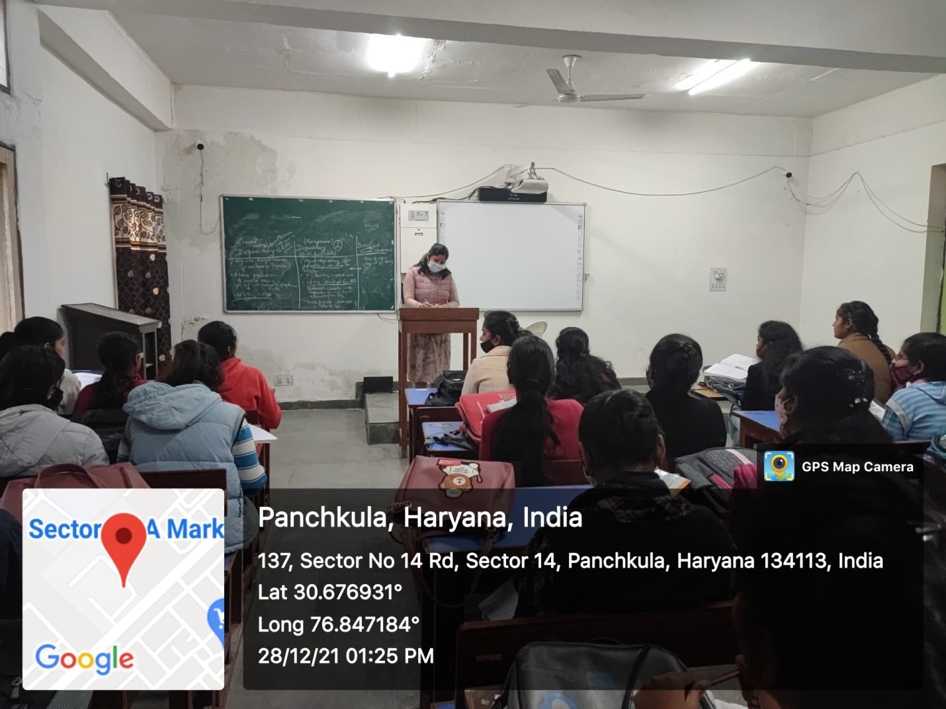

ROOM No.324
(Smart Class-Room)

