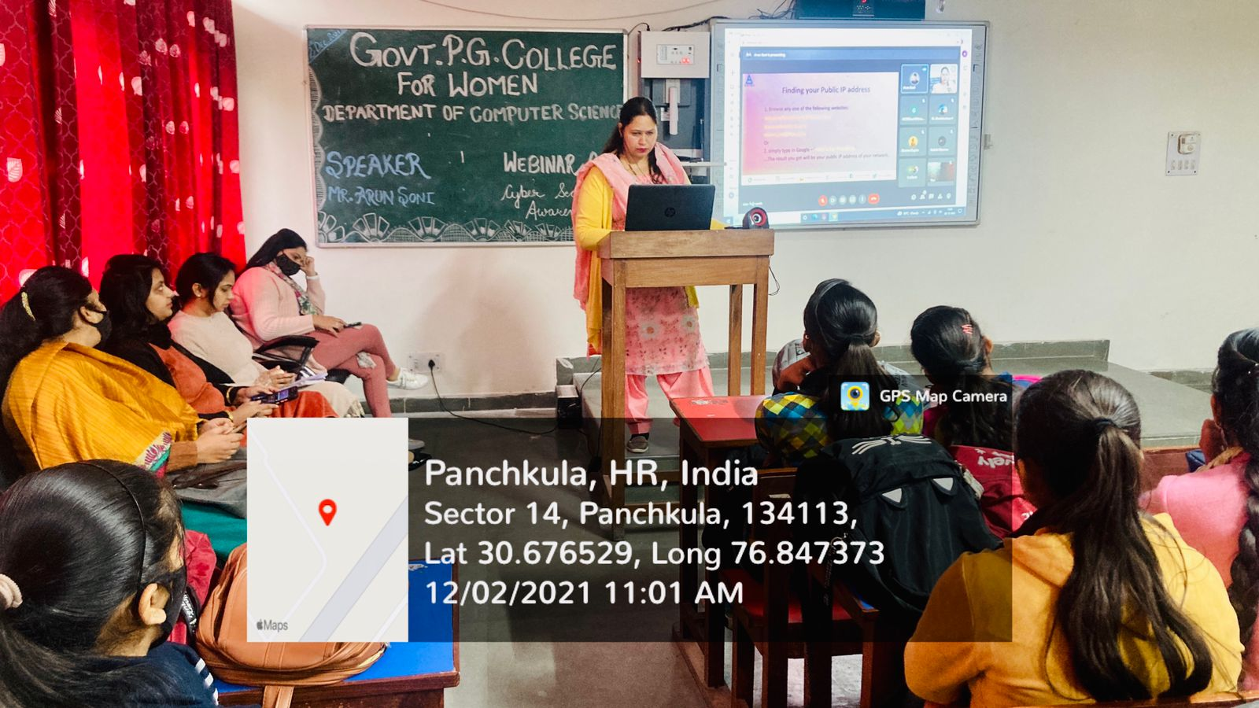
ROOM No.327
(SMART CLASS ROOM )

