**GOVT. P.G. COLLEGE FOR WOMEN, SECTOR-14, PANCHKULA**

**LESSON-PLAN (Session 2024-25) EVEN SEMESTER**

**Name of Teacher**:**Mrs. Anita Raj**

**Designation:Lecturer (Extension Lecturer)**

**Class:B.Sc. I Year (2nd Semester)**

**Subject/ Paper: Basics of Home Science II (NEP)**

**Type of course (major/ minor/ VAC/ AEC/SEC/ MDC): MDC-2**

|  |  |  |  |  |  |
| --- | --- | --- | --- | --- | --- |
| **S. No.** | **Month** | **Topics to be covered** | **Teaching Learning Strategy** | **Learning Outcomes of Students** | **Remarks** |
| **1.** | **February** | Micr   * Micro Nutrients: Definition and Classification of Vitamin and Mineral, Source, Requirement and deficiency of Vitamin: A,D, E, K, B, C (in brief) * Source, Requirement, Deficiency of Minerals: Calcium, Iron, Iodine, Sodium, Potassium * Class Test | PPT, Group  Learning and Teaching | To acquire knowledge of Vitamins and Minerals |  |
| **2.** | **March** | * Factors affecting selection of clothing., weaving-definition and different types of weaves * Meaning and Objectives of application of Finishes * Different types of Finishes- Wrinkle resistant , water resistant,  soil repellent, and flame repellent finishes * Class Test | PPT, Group  Learning and Teaching | To enable the students to have basic knowledge of Weaving, Finishing and its types | **Assign. -1**  **and Test** |
| **3.** | **April** | * Major physical, motor, emotional and cognitive development milestones through middle school age. * Role of the family and community in socialization of the child. * Developmental changes during adolescence: social, emotional, cognitive and moral development. * Class Test | PPT, Group  Learning and Teaching | To have knowledge of Major physical, motor, emotional and cognitive development milestones through middle school and adolescence. | **Assign. -2**  **and Test** |
| **4.** | **May** | * Importance of interior decoration, Elements of arts and principles of design. * Consumer protection act & consumer rights, * Standardized marks{AGMARK, FPO, WOOL MARK, ECOMARK, ISI} * Class Test | PPT, Group  Learning and Teaching | To have knowledge of elements of arts, principles and consumer protection act and rights. | **Revision and Tests** |

* **Seminar/Presentation/Assignment/Quiz/Class Test /Mid-Term Exam will be taken as per schedule.**

**Signature of Teacher**

‘

**GOVT. P.G. COLLEGE FOR WOMEN, SECTOR-14, PANCHKULA**

**LESSON-PLAN (Session 2024-25) EVENSEMESTER**

**Name of Teacher**: Ms Veenu Mittal

**Designation:** Assistant Professor

**Class: MDC**

**Subject/ Paper:** INDIAN ECONOMIC ENVIRONMENT B23-ECO-204

|  |  |  |  |  |  |
| --- | --- | --- | --- | --- | --- |
| **S. No.** | **Month** | **Topics to be covered** | **Teaching Learning Strategy** | **Learning Outcomes of Students** | **Remarks** |
| **1.** | **Feb,2025** | Elements of micro & macro environment; PESTLE analysis. Economic growth & development; primary, secondary and tertiary sectors; structural changes & emerging sectors of the Indian economy. | Group learning and teaching | To understand and analyze the nature of growth & development of India Economy. |  |
| **2.** | **March, 2025** | Review of five year plans in India, planning strategy and objectives. Current trends in industrial growth, industrial and licensing policy, growth of private sector, problems of public sector units, policy changes for industrial growth; environment for the SME sector | Group learning and teaching | Understanding and evolution of industrial sector in India. |  |
| **3.** | **April,2025** | Design and strategy of economic reforms and liberalization: India’s growth post liberalization. Main trends in imports and exports, balance of payments in recent years, environment for foreign capital and investment. | Group learning and teaching | Understanding and evolution of new economic policy in India. |  |
| **4.** | **May,2025** | Intellectual property rights and R & D environment. Banking reforms and challenges; Monetary & Fiscal Policies; meaning, importance & instruments.; SEBI; FEMA | Group learning and teaching | Utilize the detailed skills and techniques to address the problems of Indian economy like poverty, inequality, unemployment. |  |

* **Seminar/Presentation/Assignment/Quiz/Class Test /Mid-Term Exam will be taken as per schedule.**

**GOVT. P.G. COLLEGE FOR WOMEN, SECTOR-14, PANCHKULA**

**LESSON-PLAN (Session 2024-2025) Even Semester**

**Name of Professor**: **Mrs. Balwinder Kaur**

**Designation: Assistant Professor**

**Subject: Chemistry**

**Class: B.A(2nd Sem) and B.Com (2nd Sem)**

**Name of the Course: Introductory Chemistry-II**

**Course Code: B23-CHE-204**

**Subject/Paper: (MDC- Chemistry)**

|  |  |  |  |  |
| --- | --- | --- | --- | --- |
| **Months** | **Topics to be covered** | Learning outcomes of the student | **Teaching learning Strategy** | Remarks if any |
| **FEB** | **UNIT-I:**  **Renowned Indian Scientists** Brief Biography of Renowned Indian Scientists (Hargobind Khurana, Dr. P.C. Ray, Sir C.V. Raman, Dr. A.P.J. Abdul Kalam, C. N. R. Rao, Dr. Vikram Sara Bhai, Dr. Homi Jahangir Bhabha, Dr. J.C. Bose, Dr. S. N. Bose) | Student learn about Renowned Indian Scientist  To learn about role of Indian scientists in the upliftment of research | Self Study &  Group learning and teachin**g** |  |
| **MAR** | **UNIT-II:**  **Metal and Non-Metals** Periodic table, classification of elements, physical and chemical aspects of metals and non-metals, Ore and Minerals of Iron, Copper, Aluminium, alloys | learn about classification of elements with their properties | Group learning and teaching& Practical based learning., Interactive learning | **Assignment -1**  **Test** |
| **APR** | **UNIT-III:**  **Physical Properties of Matter** Classification of matter, properties, uses, ideal gas equation, real gas equation, some important compounds (baking soda, washing soda, plaster of Paris, gypsum,, glass) | To learn about three states of matter | Group learning and teaching Practical based learning, Interactive learning | **Assignment -2**  **Tests** |
| **MAY** | **UNIT-IVS:**  **Soil and fertilizers Green revolution, soil**: types of soil and their components for fertility, grow condition, pH, irrigation, biofertilizers, chemical fertilizers and their uses, acid rain.  **Revision and Tests** | To get more knowledge about role of fertilizers in fertility of soil | Group learning and teaching, Practical based learning, Interactive learning | **REVISION AND TESTS** |

**GOVT. P.G. COLLEGE FOR WOMEN, SECTOR-14, PANCHKULA**

**LESSON-PLAN (Session 2024-25) EVEN SEMESTER**

**Name of Teacher**: Dr. Neetu

**Designation:** Assistant Professor in Botany

**Class:** B.A. I (MDC-II) 2nd Sem

**Subject/ Paper:** Botany (Economic Botany)

|  |  |  |  |  |  |
| --- | --- | --- | --- | --- | --- |
| **S. No.** | **Month** | **Topics to be covered** | **Teaching Learning Strategy** | **Learning Outcomes of Students** | **Remarks** |
| 1. | **February** | Origin of Cultivated Plants, Morphology and economic importance of : Food plants - Cereals (Rice, Wheat and Maize). Pulses - Gram, Arhar and Pea. | Interactive Lectures and Discussions, Group learning and teaching. | Students will gain a foundational understanding of the origins of significant cultivated plants (Cereals and Pulses). | Submission  of Assignment 1+ Test |
| 2. | **March** | Vegetables: Potato, Tomato and Onion. Fibers: Cotton  Oils: Mustard and Coconut. | Interactive Lectures and Discussions, Group learning and teaching. | Students will develop a conceptual understanding of important plants that yield vegetables, fiber, and oil. | Power Point Presentations  And Unit Test |
| 3. | **April** | Morphology and economic importance of the following: Spices: Black pepper, Coriander, Ginger, Cloves, saffron. Medicinal Plants: Cinchona, Atropa, Opium, Cannabis, Neem. | Interactive Lectures and Discussions, Group learning and teaching. | Students will acquire knowledge about the cultivation techniques of essential plants (Spices and Medicinal Plants). | (Mid-term Exams as per Schedule), Submission  of  Assignment  2 |
| 4. | **May** | Botanical description and processing of: Beverages: Tea and Coffee. Types of wood. | Interactive Lectures and Discussions, Group learning and teaching. | Students will gain a conceptual understanding of the processing methods applied to economically significant plants. | Unit Test and  Revision |

**GOVT. P.G. COLLEGE FOR WOMEN, SECTOR-14, PANCHKULA**

**LESSON-PLAN (Session 2024-25) EVENSEMESTER**

**Name of Teacher**: Kiran Bala

**Designation: Assistant Professor**

**Class:** MDC 2nd Sem. BA I/B.Sc I(Life Sc.) (B23-MAT-204)

**Subject/ Paper:** Mathematics for Commerce and Social Sciences

|  |  |  |  |  |  |
| --- | --- | --- | --- | --- | --- |
| **S. No.** | **Month** | **Topics to be covered** | **Teaching Learning Strategy** | **Learning Outcomes of Students** | **Remarks** |
| **1.** | **February** | Matrices and Determinants: Definition of a matrix, Order, Equality, Types of matrices, Operations on matrices: addition, multiplication and multiplication with a scalar and their simple properties. Minors, Co-factors, Determinant, Properties of determinants and applications of determinants in finding the area of a triangle, Adjoint and inverse of a square matrix, Solutions of simultaneous linear equations. | **Group- Learning and Teaching**  **Learning through Problem Solving** | Understand and have the procedural knowledge of the concepts of matrices and determinants to solve simultaneous linear equations. |  |
| **2.** | **March** | Differentiation, Derivatives of simple functions and other functions having applications in business and social studies, Maxima and minima of a function and their applications to Revenue, Cost, Demand, Production, Profit functions and other functions related to commercial and social Problems. Integration of simple functions and its applications in commercial and economic problems.. | **Group- Learning and Teaching**  **Learning through Problem Solving** | Gain the knowledge to find derivatives and integration of simple functions related to commerce and social sciences. Acquire skills to make use of derivatives and integration in realistic problems of the discipline. |  |
| **3.** | **April** | Simple interest and compound interest. Annuities: Types of annuities, Present value and amount of an annuity (including the case of continuous compounding), Valuation of simple loans and debentures, Problems related to sinking funds. | **Group- Learning and Teaching**  **Learning through Problem Solving** | Have the conceptual knowledge of compound interest, annuity, loan, debenture and sinking funds and attain skills to use these concepts in problem solving. |  |
| **4.** | **May** | Linear Programming: Formulation of linear programming problems (LPP) and their solution by graphical and Simplex methods. Applications of linear programming in solving social science and business problems. | **Group- Learning and Teaching**  **Learning through Problem Solving** | Gain the knowledge and understanding of the concepts of Linear programming and develop skills of formulating and solving linear programming problems based on real world problems. |  |

* **Seminar/Presentation/Assignment/Quiz/Class Test /Mid-Term Exam will be taken as per schedule.**

**Signature of Teacher Principal**

**GOVT. P.G. COLLEGE FOR WOMEN, SECTOR-14, PANCHKULA**

**LESSON-PLAN (Session 2024-25) EVEN SEMESTER**

**Name of Teacher**: Dr. Neetu

**Designation:** Assistant Professor in Botany

**Class:** B.A. I (MDC-II) 2nd Sem

**Subject/ Paper:** Botany (Economic Botany)

|  |  |  |  |  |  |
| --- | --- | --- | --- | --- | --- |
| **S. No.** | **Month** | **Topics to be covered** | **Teaching Learning Strategy** | **Learning Outcomes of Students** | **Remarks** |
| 1. | **February** | Origin of Cultivated Plants, Morphology and economic importance of : Food plants - Cereals (Rice, Wheat and Maize). Pulses - Gram, Arhar and Pea. | Interactive Lectures and Discussions, Group learning and teaching. | Students will gain a foundational understanding of the origins of significant cultivated plants (Cereals and Pulses). | Submission  of Assignment 1+ Test |
| 2. | **March** | Vegetables: Potato, Tomato and Onion. Fibers: Cotton  Oils: Mustard and Coconut. | Interactive Lectures and Discussions, Group learning and teaching. | Students will develop a conceptual understanding of important plants that yield vegetables, fiber, and oil. | Power Point Presentations  And Unit Test |
| 3. | **April** | Morphology and economic importance of the following: Spices: Black pepper, Coriander, Ginger, Cloves, saffron. Medicinal Plants: Cinchona, Atropa, Opium, Cannabis, Neem. | Interactive Lectures and Discussions, Group learning and teaching. | Students will acquire knowledge about the cultivation techniques of essential plants (Spices and Medicinal Plants). | (Mid-term Exams as per Schedule), Submission  of  Assignment  2 |
| 4. | **May** | Botanical description and processing of: Beverages: Tea and Coffee. Types of wood. | Interactive Lectures and Discussions, Group learning and teaching. | Students will gain a conceptual understanding of the processing methods applied to economically significant plants. | Unit Test and  Revision |

* **Seminar/Presentation/Assignment/Quiz/Class Test /Mid-Term Exam will be taken as per schedule.**

**GOVT. P.G. COLLEGE FOR WOMEN, PANCHKULA**

**Session 2024-25 (EVEN SEMESTER)**

NAME OF PROFESSOR :Vibha Madan

DESIGNATION: Assistant Professor in Psychology

SUBJECT/PAPER: Understanding Abnormal Behaviour (B23-PSY-203)

CLASS :MDC Psychology (2 ndsemester)

|  |  |  |  |  |  |
| --- | --- | --- | --- | --- | --- |
| SR. NO. | MONTH | TOPICS TO BE COVERED | Teaching Learning Strategy | Learning outcomes of students | REMARKS |
| 1. | February,  2025 | Abnormal Behaviour: Meaning, Criteria and Characteristics. Causes of Abnormal Behaviour | Classroom discussion& student centered strategy  Learning by giving notes and assignments  (Assignment based learning)  Summative assessment strategy  Experiential learning | In this curriculum, students learn aboutmild ,moderate and severemental disorders,causes and criteria of abnormal behaviour. |  |
| 2. | March,2025 | Models of Abnormality  -Biological, Psychologicaland Socio- cultural. | Classroom discussion & student centered strategy  Learning by giving notes and assignments  (Assignment based learning)  Summative assessment strategy  Experiential learning | The students also learn about models of abnormality which further helps them to know biological, psychological and socio-cultural viewpoints and perspectives. |  |
| 3. | April,2025 | Anxiety Based Disorders: Obsessive Compulsive Disorder, Phobia, Panic Attack: Etiology and Management.  Mood Disorder: Types and Causes.  . | Classroom discussion & student centered strategy  Learning by giving notes and assignments  (Assignment based learning)  Summative assessment strategy  Experiential learning | The students learn about the various anxiety based disorders like OCD, phobia, panic attack and its management. The students also learn about mood disorders. |  |
| 4. | May,2025 | Psychotherapies: Psychoanalysis, Behaviour Therapy and Cognitive Behaviour Therapy. | Classroom discussion & student centered strategy  Learning by giving notes and assignments  (Assignment based learning)  Summative assessment strategy  Experiential learning | The students learn how to apply therapeutic procedure for the treatment disorders such as mood disorders, anxiety disorders, schizophrenia etc and various psychotherapy techniques (therapies) like Psychotherapy, behaviour therapy and Cognitive Behaviour Therapy. |  |

**TWO ASSIGNMENTS AND ONE MID TERM EXAM WILL BE TAKEN AS PER SCHEDULE**

Signature of A/Prof .

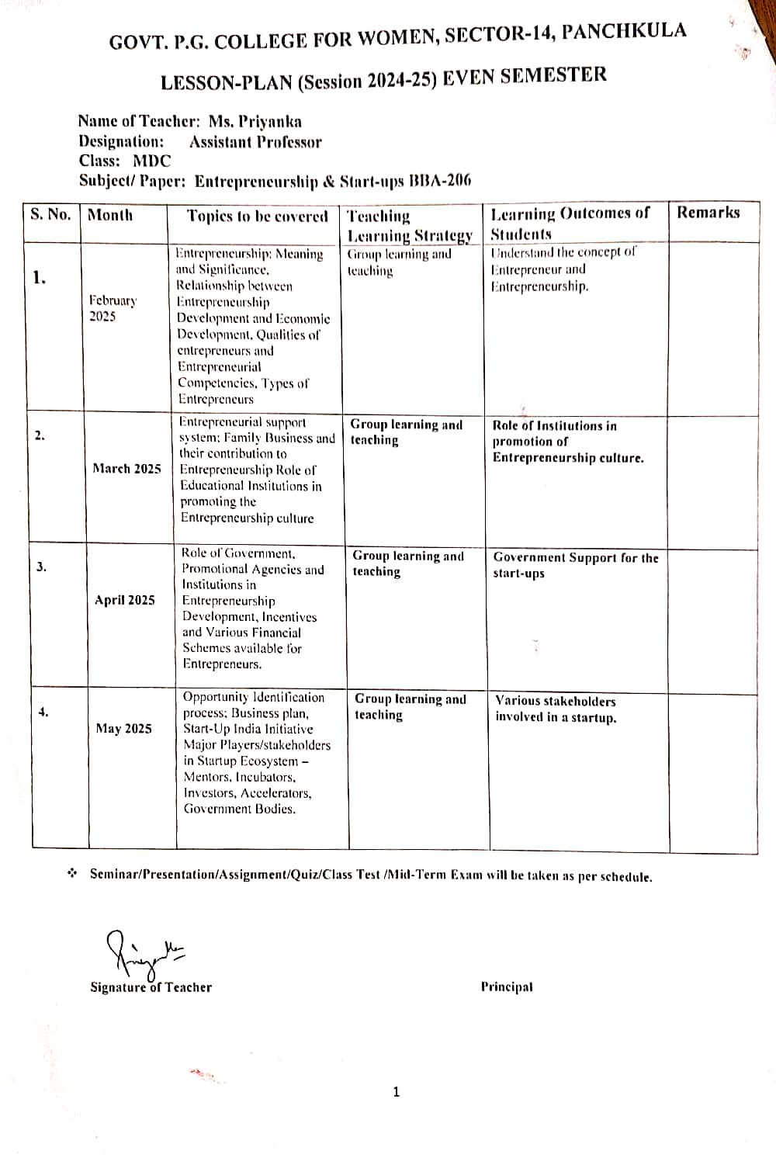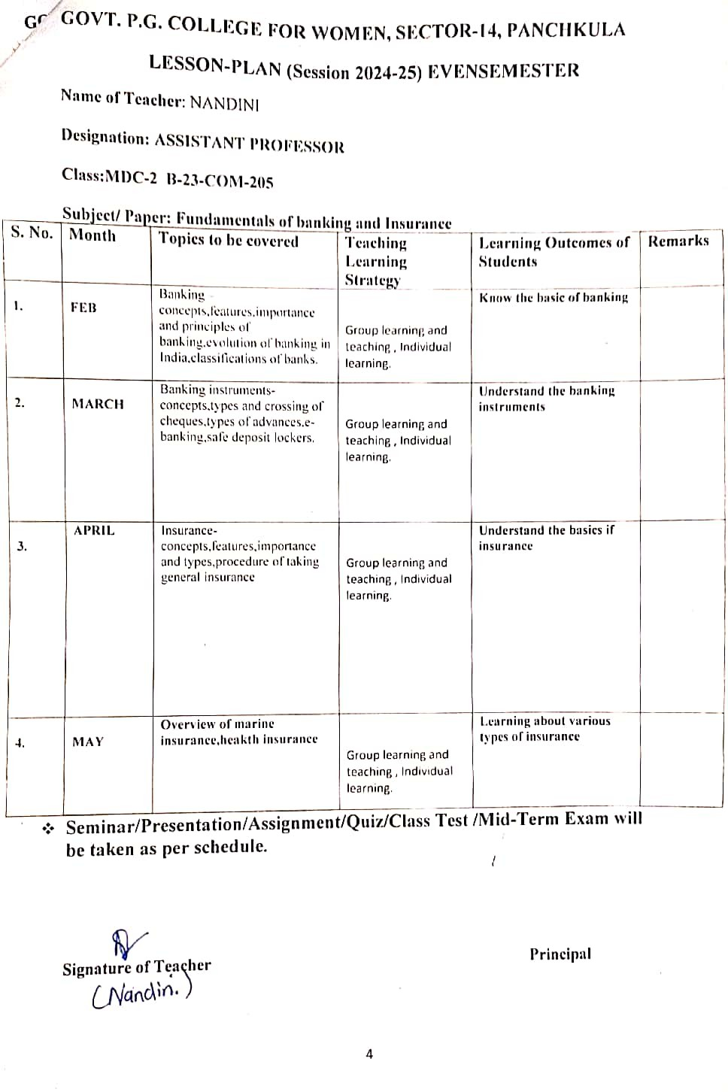

**GOVT. P.G. COLLEGE FOR WOMEN, SECTOR-14, PANCHKULA**

**LESSON-PLAN (Session 2024-25) EVENSEMESTER**

**Name of Teacher**: Ms Veenu Mittal

**Designation:** Assistant Professor

**Class: MDC**

**Subject/ Paper:** INDIAN ECONOMIC ENVIRONMENT B23-ECO-204

|  |  |  |  |  |  |
| --- | --- | --- | --- | --- | --- |
| **S. No.** | **Month** | **Topics to be covered** | **Teaching Learning Strategy** | **Learning Outcomes of Students** | **Remarks** |
| **1.** | **Feb,2025** | Elements of micro & macro environment; PESTLE analysis. Economic growth & development; primary, secondary and tertiary sectors; structural changes & emerging sectors of the Indian economy. | Group learning and teaching | To understand and analyze the nature of growth & development of India Economy. |  |
| **2.** | **March, 2025** | Review of five year plans in India, planning strategy and objectives. Current trends in industrial growth, industrial and licensing policy, growth of private sector, problems of public sector units, policy changes for industrial growth; environment for the SME sector | Group learning and teaching | Understanding and evolution of industrial sector in India. |  |
| **3.** | **April,2025** | Design and strategy of economic reforms and liberalization: India’s growth post liberalization. Main trends in imports and exports, balance of payments in recent years, environment for foreign capital and investment. | Group learning and teaching | Understanding and evolution of new economic policy in India. |  |

**GOVT. P.G. COLLEGE FOR WOMEN, SECTOR-14, PANCHKULA**

**LESSON-PLAN (Session 2024-25) EVEN SEMESTER**

**Name of Teacher: DR. SEEMA**

**Designation: ASSISTANT PROFESSOR**

**Class:U.G FIRST YEAR**

**Subject/ Paper:Web Technologies Fundamentals**

**Type of course( major/ minor/VAC/ AEC/SEC/ MDC): MDC**

|  |  |  |  |  |  |
| --- | --- | --- | --- | --- | --- |
| **S. No.** | **Month** | **Topics to be covered** | **Teaching Learning Strategy** | **Learning Outcomes of Students** | **Remarks** |
| **1.** | **FEB** | Introduction to Internet and World Wide Web (WWW); Evolution  and History of World Wide Web, Web Pages and Contents, Web  Clients, Web Servers, Web Browsers; Hypertext Transfer Protocol,  URLs; Searching, Search Engines and Search Tools | **Problem Solving, Self Learning** | **learn the basics of web development** | **ASSIGNMENT1** |
| **2.** | **MAR** | Web Publishing: Hosting website; Internet Service Provider;  Planning and designing website; Web Graphics Design, steps for  Developing website  Creating a Website and Introduction to Markup Languages (HTML  and DHTML) | **Group based learning, Problem solving** | **understand different types of web pages and**  **websites** | **TEST** |
| **3.** | **APRIL** | HTML Document Features & Fundamentals, HTML Elements,  Creating Links; Headers; Text styles; Text Structuring; Text color  and Background; Formatting text; Page layouts, Images; Ordered and  Unordered lists; Inserting Graphics; Table Creation and Layouts;  Frame Creation and Layouts; Working with Forms and Menus;  Working with Radio Buttons; Check Boxes; Text Boxes, HTML5 | **Group learning,** | **Implement HTML and CSS for web page designing** | **ASSIGNMENT2** |
| **4.** | **MAY** | Introduction to CSS (Cascading Style Sheets): Features, Core Syntax,  Types, Style Sheets and HTML, Style Rule Cascading and  Inheritance, Text Properties, CSS Box Model, Normal Flow Box  Layout, Positioning, and other useful Style Properties; Features of  CSS3. Introduction to Client–Side Programming | **PROBLEM SOLVING** | Understand the design of web crawlers and search  engines | **REVISION** |

* **Seminar/Presentation/Assignment/Quiz/Class Test /Mid-Term Exam will be taken as per schedule.**

**Signature of Teacher Principal**