**Report**

**Name of Activity: Workshop/Coaching Camp for Yoga Championship**

**Organized by:- Sports Department and Yoga Club**

**Date:- 2nd to 14th March,2024.**

Yoga Workshop was conducted from 26th February to 14th March, 2024 to train students for Yoga Championship at 12:00-1:30 PM. The workshop was organized for the preparation of College Yoga Team.

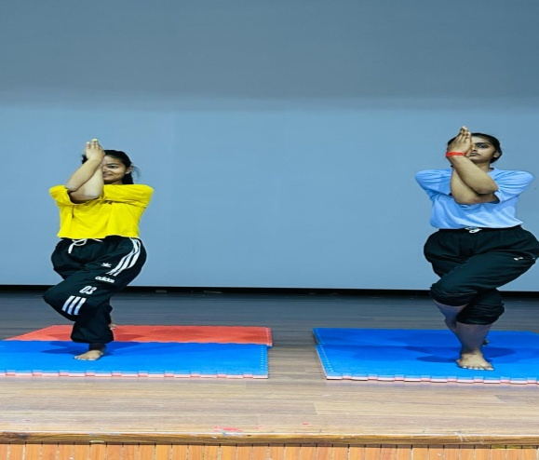The selected 15 students practiced in training camp for the Yoga Championship, which was held on 15th to 17th March 2024. Mr. Pardeep Kumar was Yoga Coach for the Workshop. He trained the students technically and tactically to perform well in the Championship.

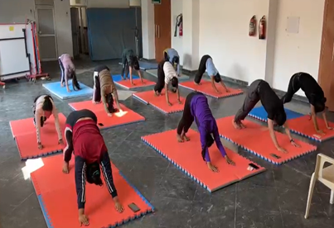

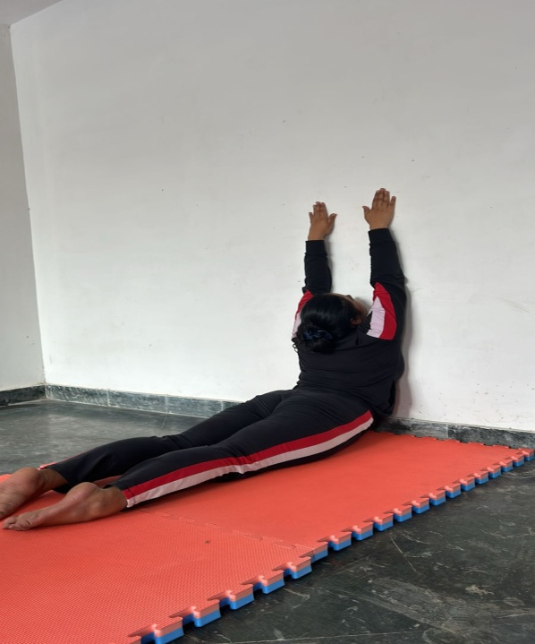

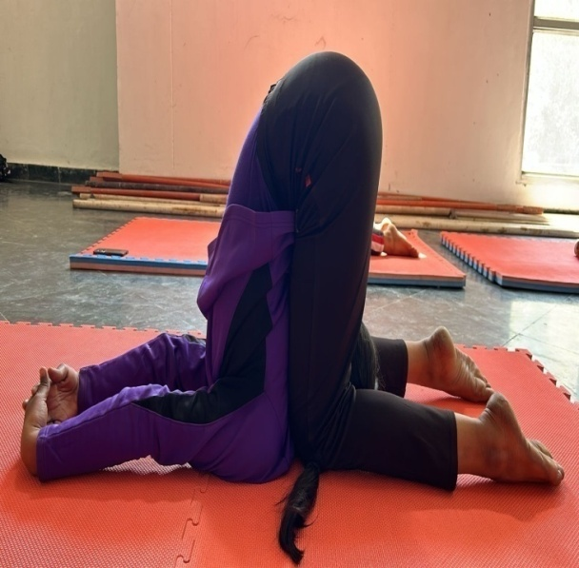

**Report of Inter Collegiate State Yoga Championship (Men & Women) from 15th to 17th March 2024**

* Inter Collegiate State Yoga Championship (Men & Women) sponsored by Directorate of Higher Education (DGHE) was conducted by Government P.G. College for Women, Sec-14, Panchkula from 15th March to 17th march 2024.
* Total 21 teams participated in Competition, including 8 teams in Men’s category and 13 teams in Women’s category.
* Cash prize money 25000, 15000 and 10000 for the first, second and third position respectively were given as per DGHE instructions .
* Trophies and Merit Certificates were also given to the winning teams and Trophies and cash prize money were also given for “Best Yogi” and “Best Yogini”.
* Boarding/Lodging facilities were also provided by the host college.
* Mr.Virender Singh ,Government College for Women, Tosham Bhiwani were the Observer for the tournament appointed by the DGHE.

**First day of Championship**:

* Shri Vineet Garg I.A.S additional Chief Secretary, Higher Education Haryana were Chief Guest of the opening ceremony of the event on 15th March 2024.
* Total 21 teams participated in the first round, first day of the event and 8 teams qualified for the next round.

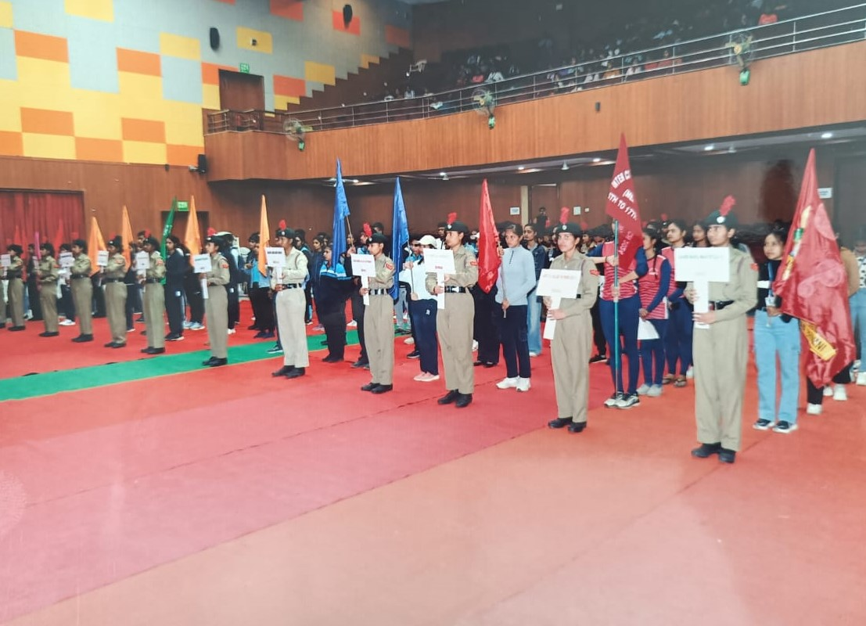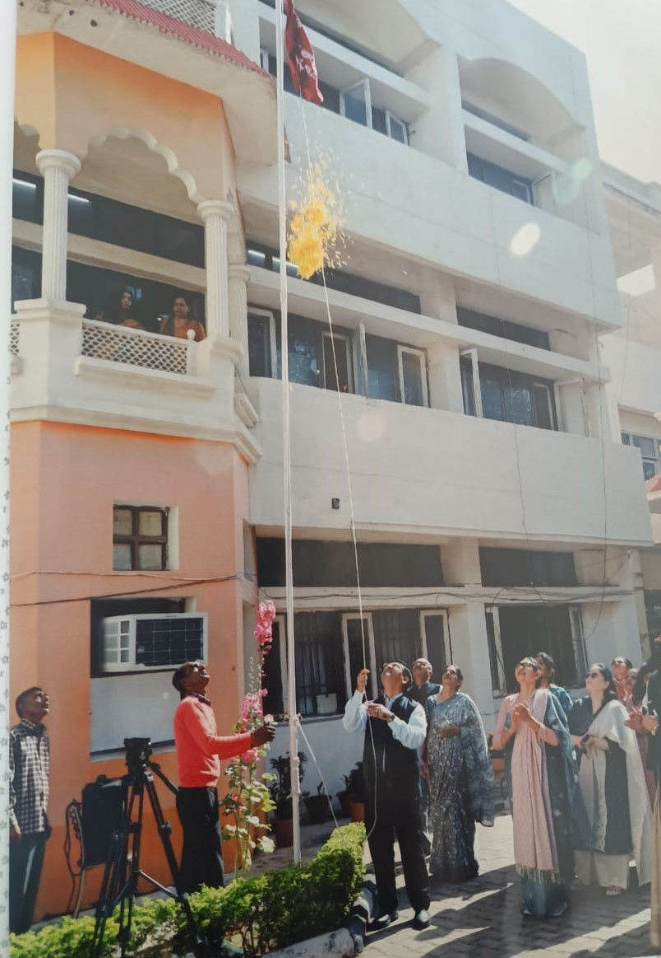

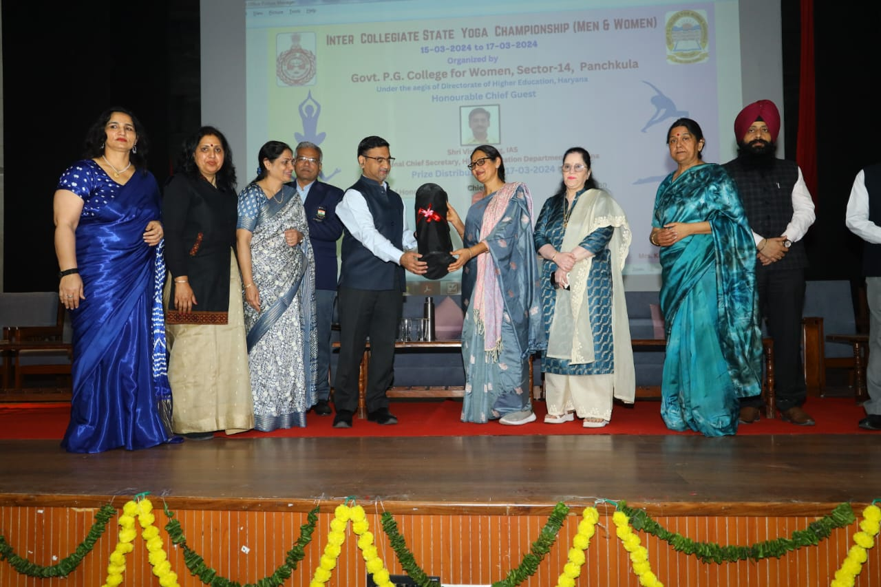

**Second day of Championship**:

* Total 8 teams participated and two teams were selected from Women’s category and two teams were selected from Men’s category for the final round.

**Third day of Championship**:

* On the final day Padama Shri Awardee Smt. Mamta Sauda ACP, Panchkula were the Chief Guest of Closing Ceremony of the event on 17th March 2024.
* Dr. Kuldeep Beniwal, Deputy Director, Sports (Retd.) were Guest of Honor of the event.
* Final round in both the categories and match for 3rd place were played on the third day.

**Final result for Championship In Women’s Category:-**

1st Position -Adarsh Mahila Mahavidyalaya, Bhiwani

2nd Position- Rajiv Gandhi College For Women, Bhiwani

3rd Position- Maharishi Valmiki Sanskrit University, Kaithal

**Final result for Championship In Men’s Category:-**

1st Position – Maharishi Valmiki Sanskrit University, Kaithal

2nd Position- Dayanand College, Hisar

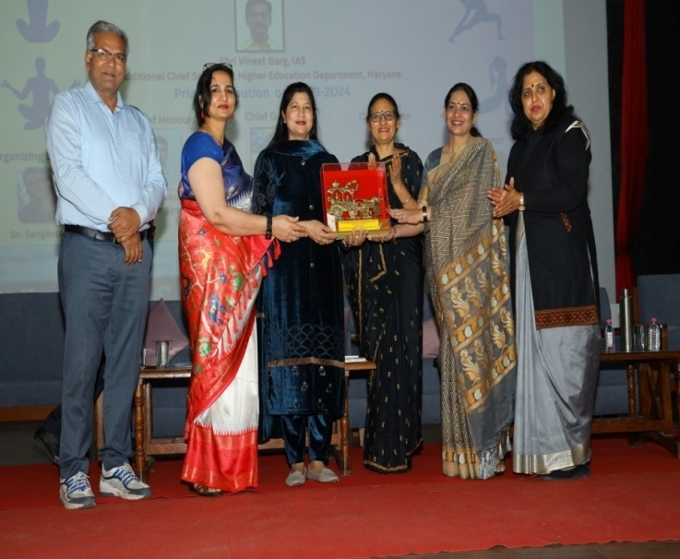 3rd Position- Government College, Hansi

